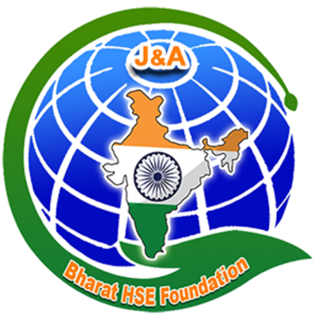 |  | 

J&A Bharat HSE Foundation –

DL Shah Trust HSES Awards

PURPOSE & ELIGIBILITY
The J&ABHF & DL Shah Trust Award is an honor acknowledging the dedication and outstanding contributions in the field of HSE&S. To be eligible, nominees must:
- Be in good standing in the profession of HSE&S
- Not have received this award within the past five (5) years
- Be engaged in full-time employment in the profession of Occupational Health & Safety, Environment and Sustainability.
- Nominees work location must be within India
- Nominees are not eligible if they are currently serving as a member of the Awards and Honors Evaluation Committee

JUDGING CRITERIA
The nominee’s most recent three (3) years of activities will be considered as a minimum.
- Demonstrated technical expertise in the broad field of HSE&S and a thorough knowledge of the operational aspects of his/her employment.
- Demonstrated outstanding contributions in professional organization activities, including committee or task force chair, officer, mentoring services to fellow professionals, speaker at seminars, etc.
- Leadership in establishment, maintenance, and improvement of technical or Professional Organizations like J&ABHF or any other similar organizations.
- Other personal achievements related to HSE&S.
- Professional contributions to advance the HSE&S profession, such as fostering professional development, public/community services, instructor at educational institutions, involvement in codes and legislation, articles written, publications, work with allied groups, etc.
- Awards and innovations, including citations, honors, plaques; or new procedures or systems developed.
- Endorsements by superiors and verifications by associates, in the form of letters on appropriate stationery of the employer or organizat

Nomination Form : Link

Endorsement Form : Link

